Test Case: runTestMultipleTimes
Step 1 - Enter username and password and click to button Enter : Credentials Entered
Image file-name: QC_Testing-runTestMultipleTimes-nov. 25 2025, 03 32 18 p. m.

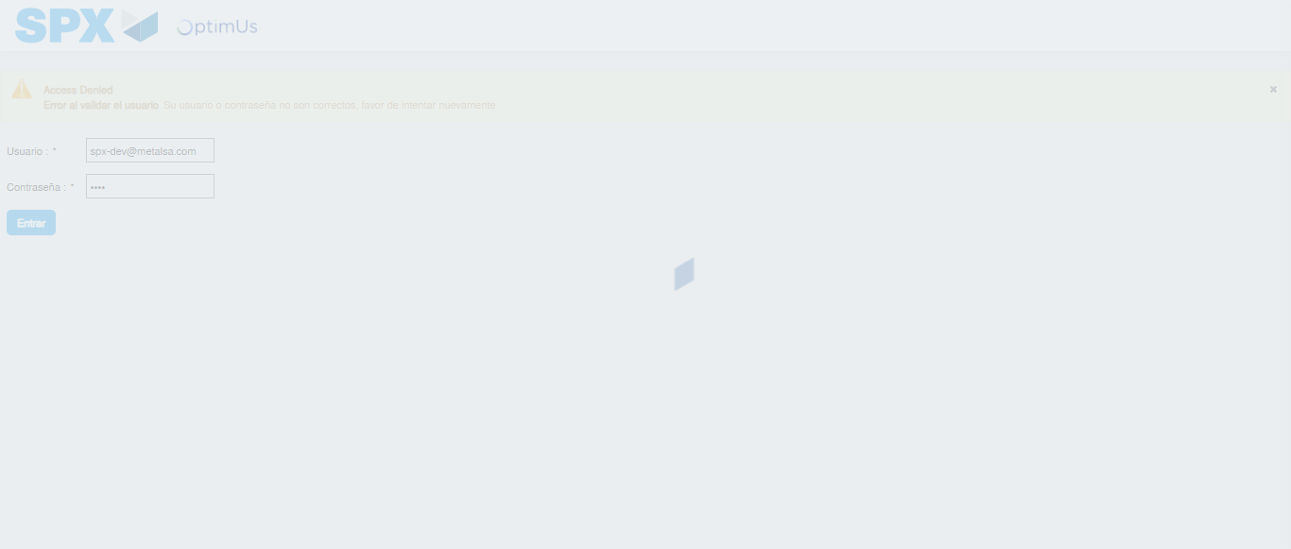Image file-name: QC_Testing-runTestMultipleTimes-nov. 25 2025, 03 32 19 p. m.

Step 2 - Select to UEN and Access to Spot Buy Requisitions : UEN Correctly selected and Correct access
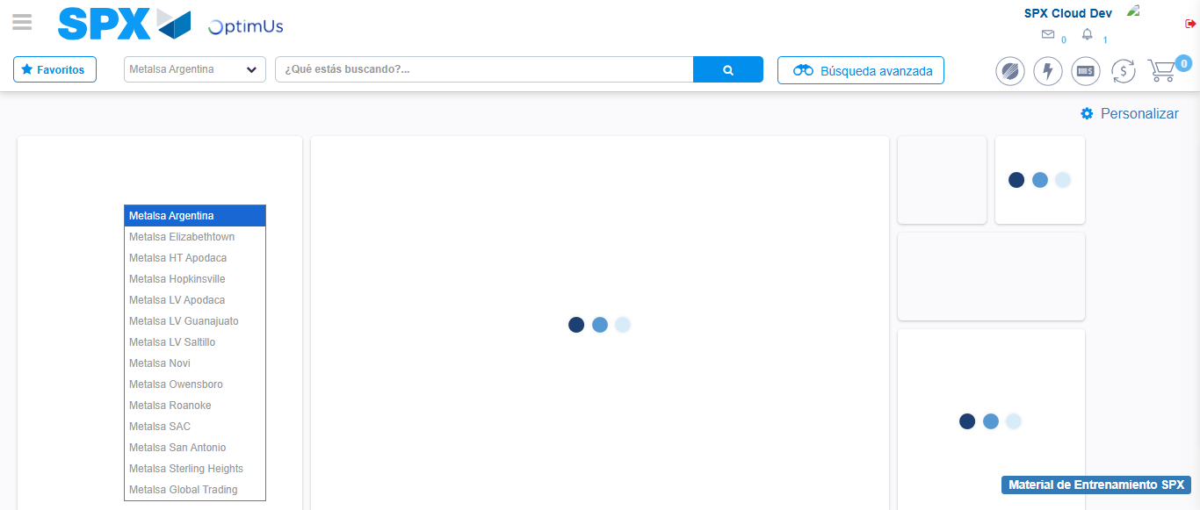Image file-name: QC_Testing-runTestMultipleTimes-nov. 25 2025, 03 32 22 p. m.

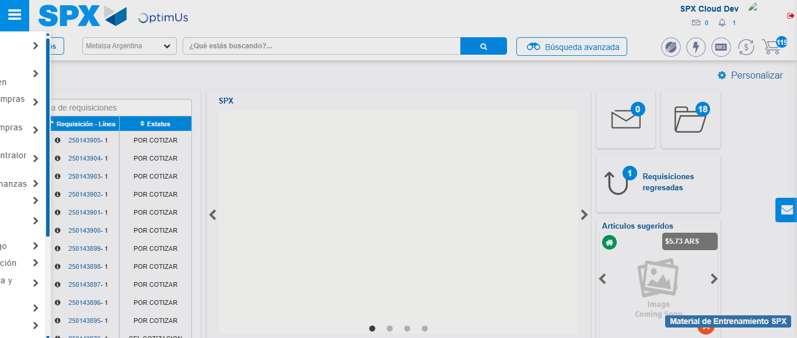Image file-name: QC_Testing-runTestMultipleTimes-nov. 25 2025, 03 32 23 p. m.

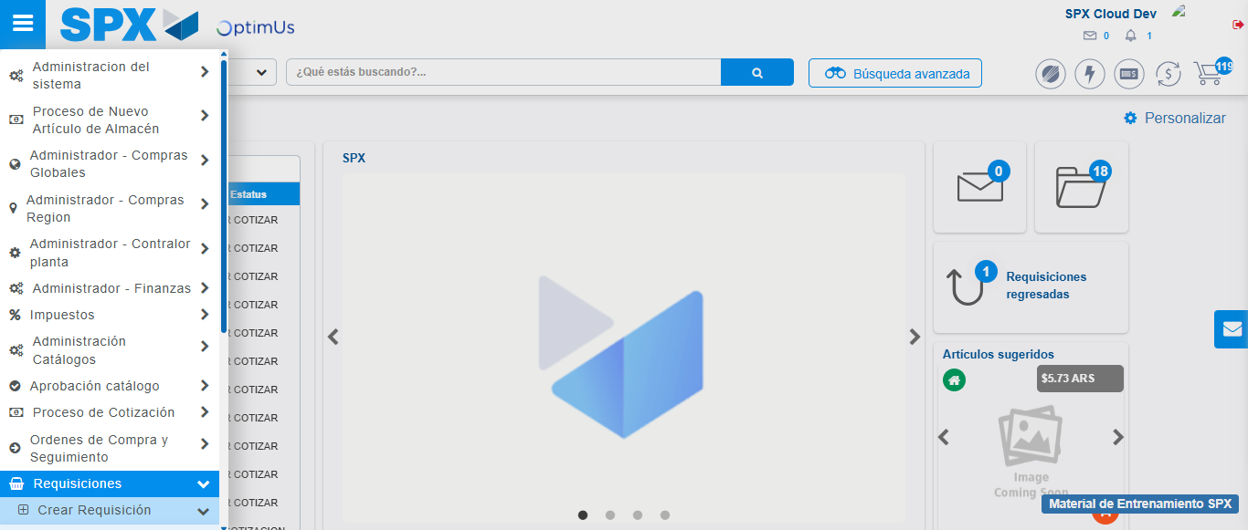Image file-name: QC_Testing-runTestMultipleTimes-nov. 25 2025, 03 32 24 p. m.

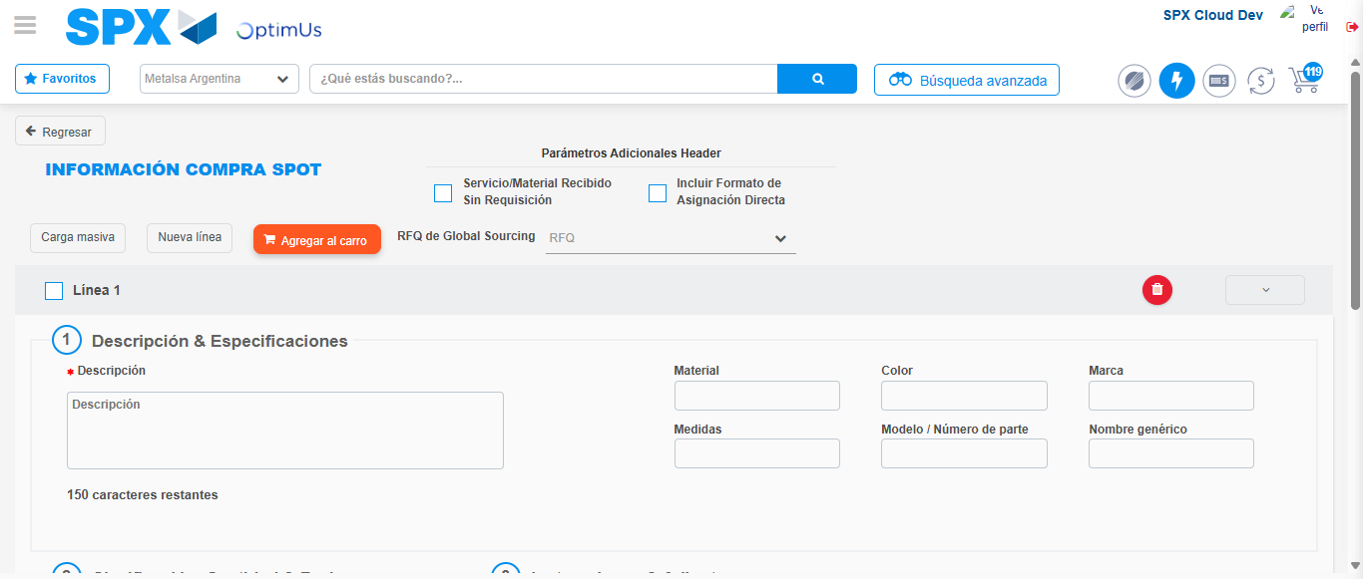Image file-name: QC_Testing-runTestMultipleTimes-nov. 25 2025, 03 32 29 p. m.

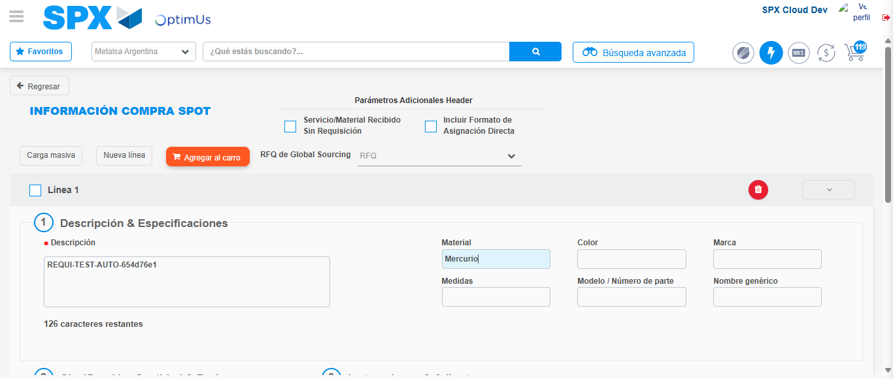Image file-name: QC_Testing-runTestMultipleTimes-nov. 25 2025, 03 32 30 p. m.

Step 3 - Data Capture Spot Buy Requisition : Data captured correctly
Image file-name: QC_Testing-runTestMultipleTimes-nov. 25 2025, 03 32 30 p. m.

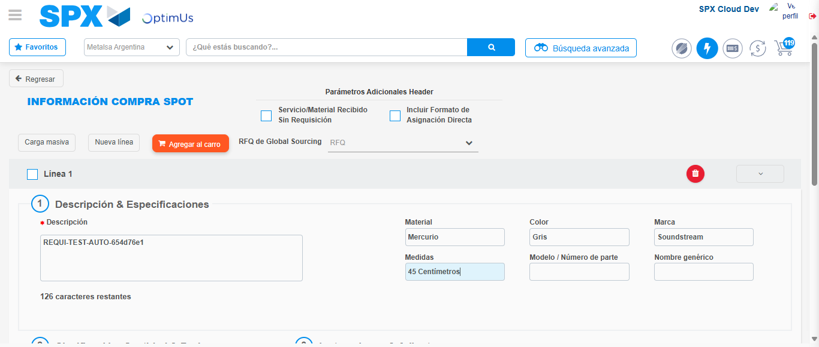Image file-name: QC_Testing-runTestMultipleTimes-nov. 25 2025, 03 32 31 p. m.

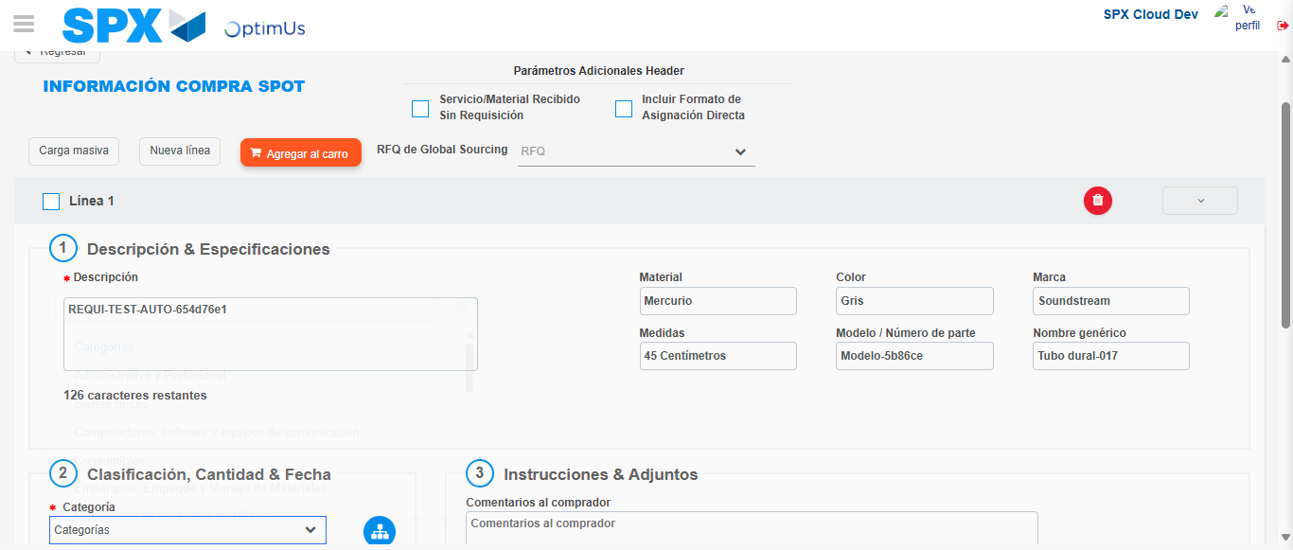Image file-name: QC_Testing-runTestMultipleTimes-nov. 25 2025, 03 32 32 p. m.

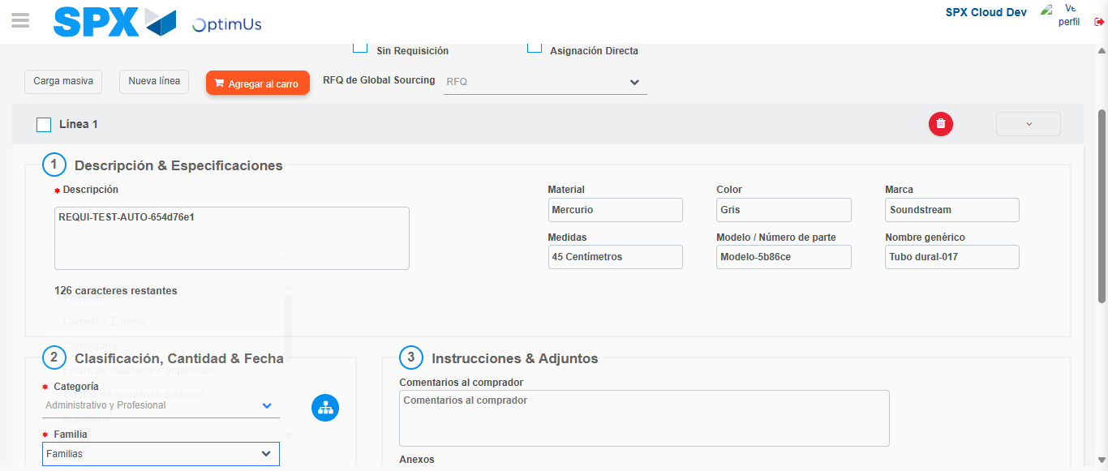Image file-name: QC_Testing-runTestMultipleTimes-nov. 25 2025, 03 32 33 p. m.

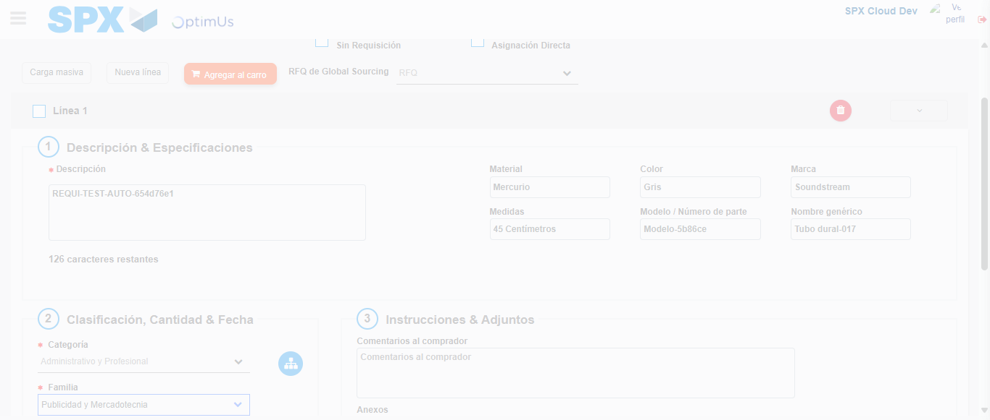Image file-name: QC_Testing-runTestMultipleTimes-nov. 25 2025, 03 32 34 p. m.

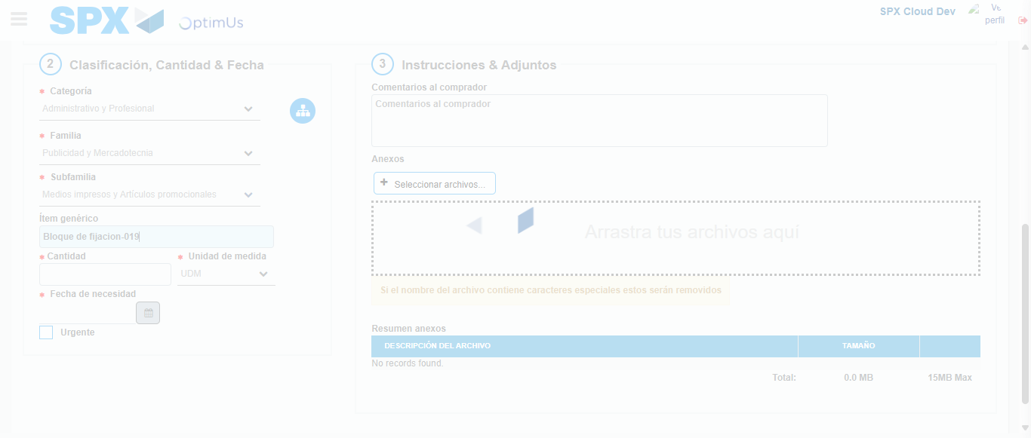Image file-name: QC_Testing-runTestMultipleTimes-nov. 25 2025, 03 32 35 p. m.

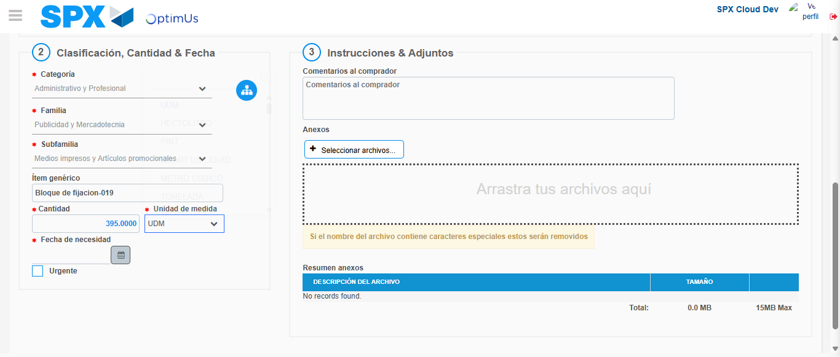Image file-name: QC_Testing-runTestMultipleTimes-nov. 25 2025, 03 32 36 p. m.

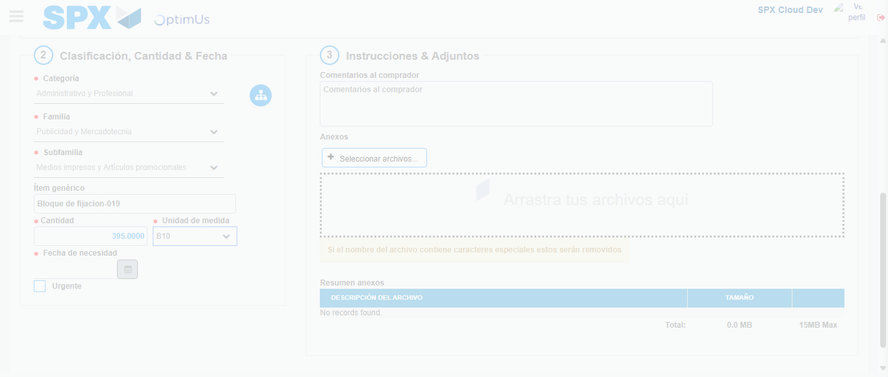Image file-name: QC_Testing-runTestMultipleTimes-nov. 25 2025, 03 32 37 p. m.

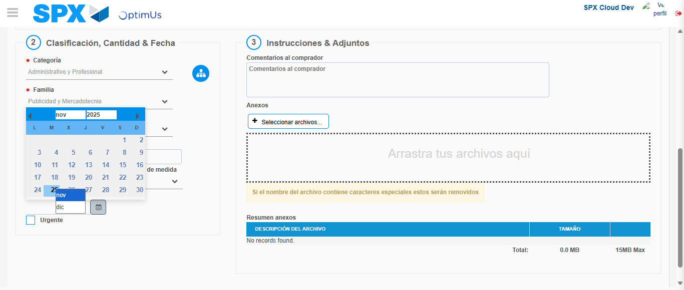Image file-name: QC_Testing-runTestMultipleTimes-nov. 25 2025, 03 32 38 p. m.

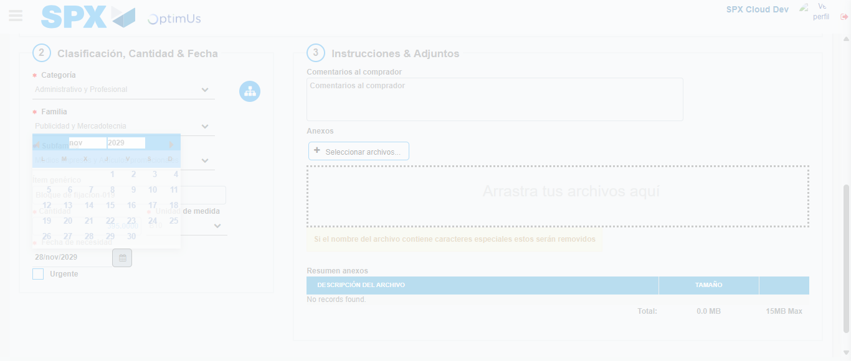Image file-name: QC_Testing-runTestMultipleTimes-nov. 25 2025, 03 32 39 p. m.

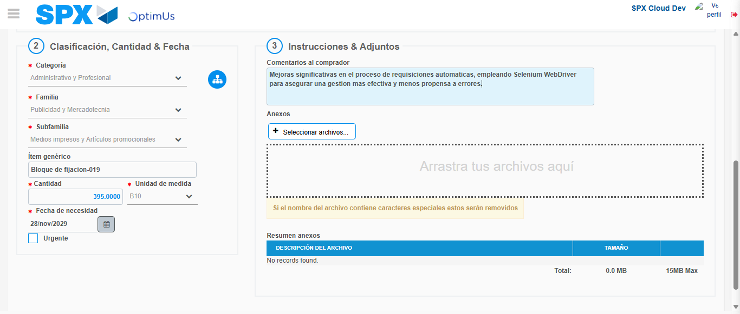Image file-name: QC_Testing-runTestMultipleTimes-nov. 25 2025, 03 32 40 p. m.

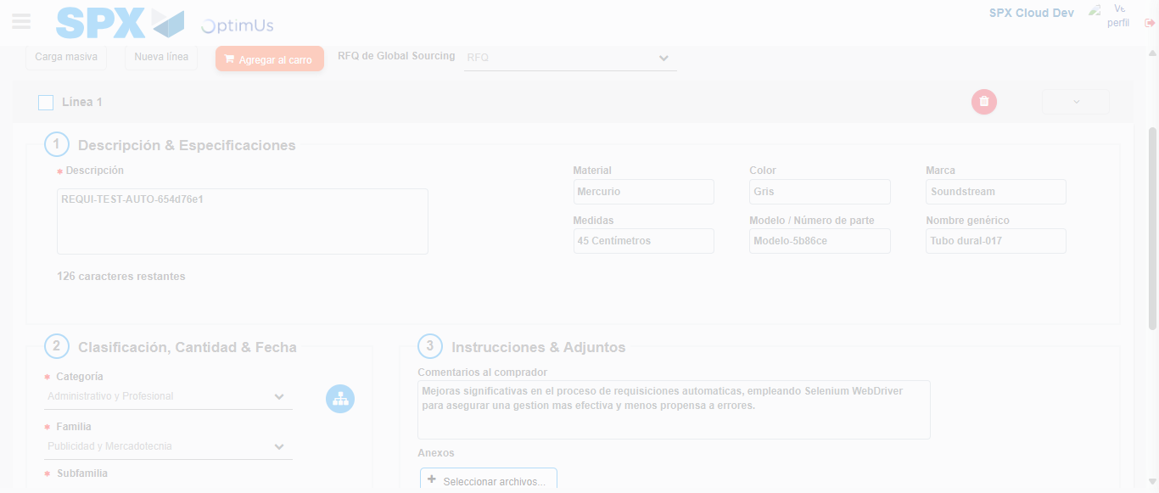Image file-name: QC_Testing-runTestMultipleTimes-nov. 25 2025, 03 32 41 p. m.

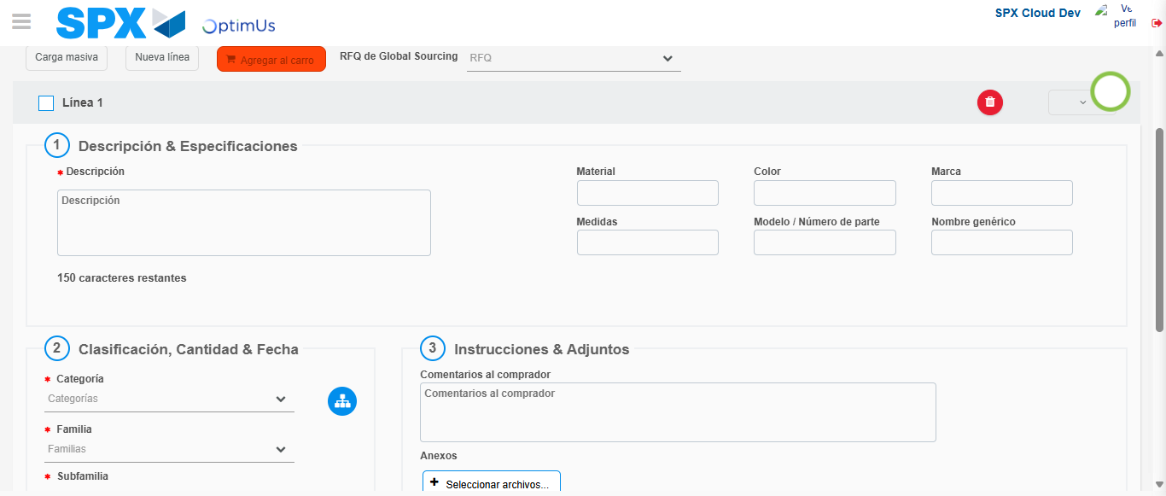Image file-name: QC_Testing-runTestMultipleTimes-nov. 25 2025, 03 32 42 p. m.

Step 4 - Select to Requisition : Requisition Correctly selected
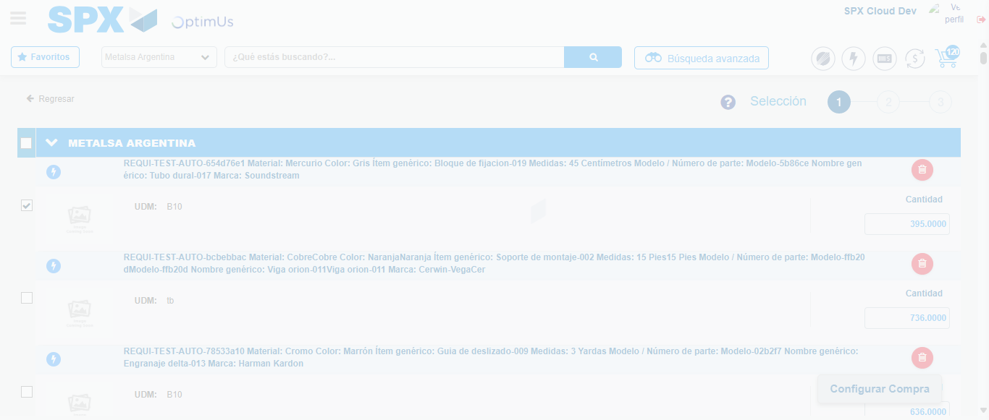Image file-name: QC_Testing-runTestMultipleTimes-nov. 25 2025, 03 32 50 p. m.

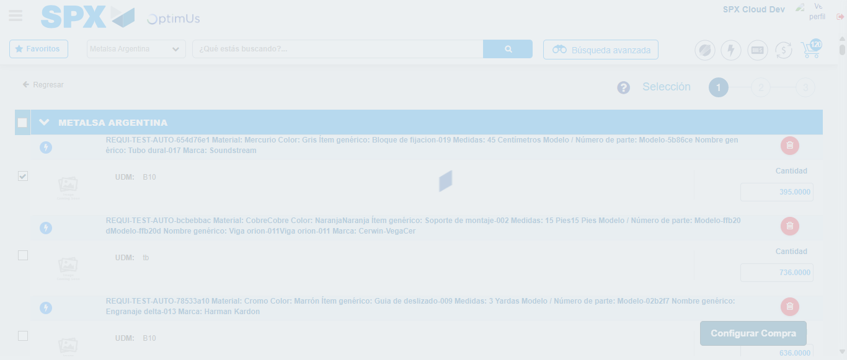Image file-name: QC_Testing-runTestMultipleTimes-nov. 25 2025, 03 32 54 p. m.

Step 5 - Select Type Account For Requisition : Type Account Correctly selected
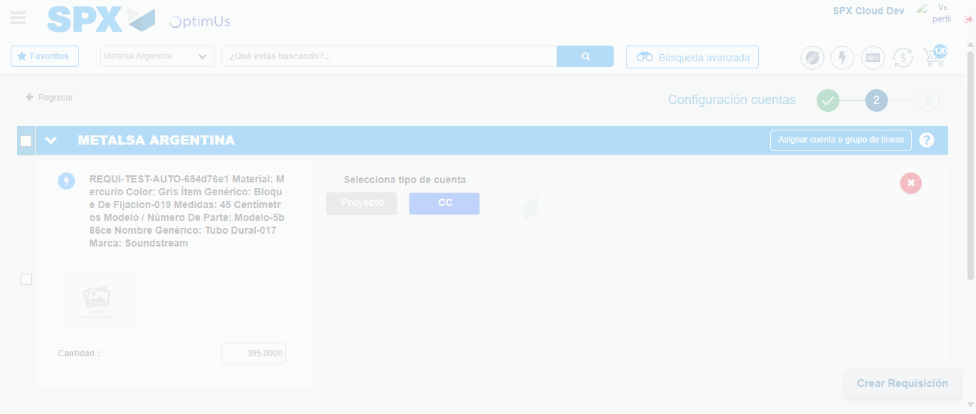Image file-name: QC_Testing-runTestMultipleTimes-nov. 25 2025, 03 32 58 p. m.

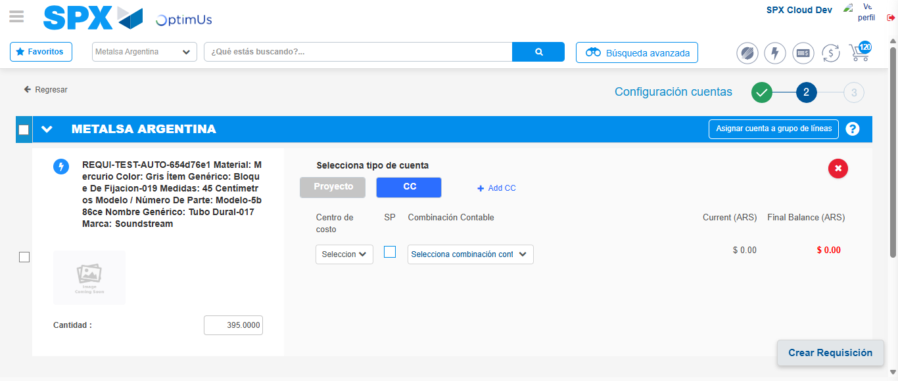Image file-name: QC_Testing-runTestMultipleTimes-nov. 25 2025, 03 33 01 p. m.

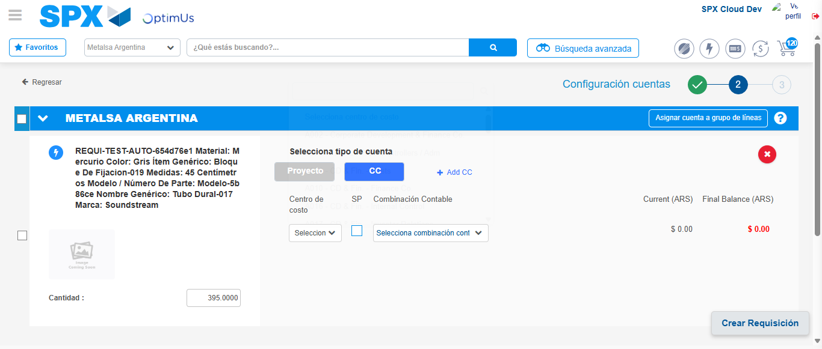Image file-name: QC_Testing-runTestMultipleTimes-nov. 25 2025, 03 33 04 p. m.

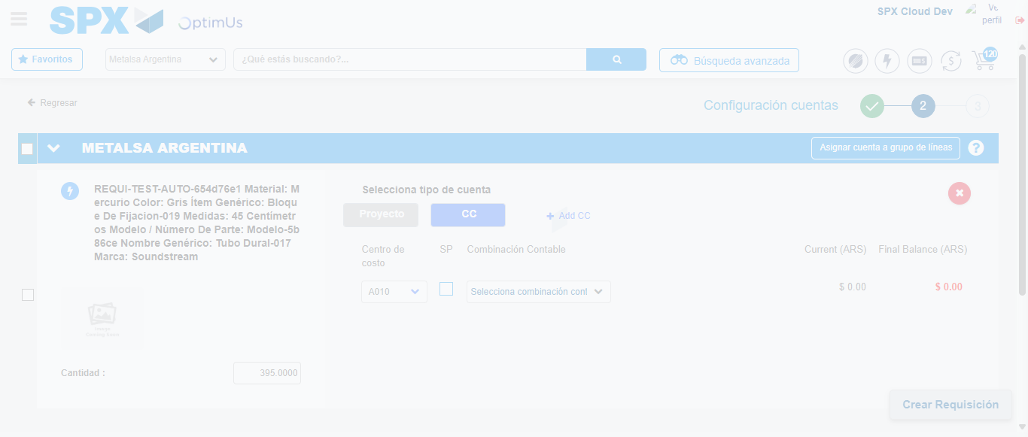Image file-name: QC_Testing-runTestMultipleTimes-nov. 25 2025, 03 33 05 p. m.

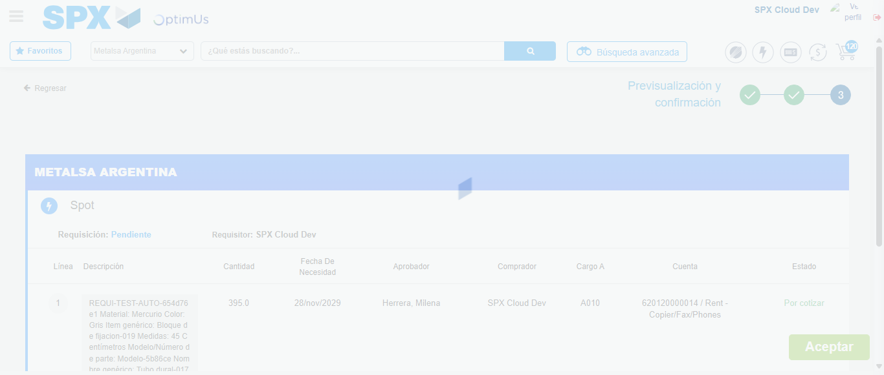Image file-name: QC_Testing-runTestMultipleTimes-nov. 25 2025, 03 33 08 p. m.

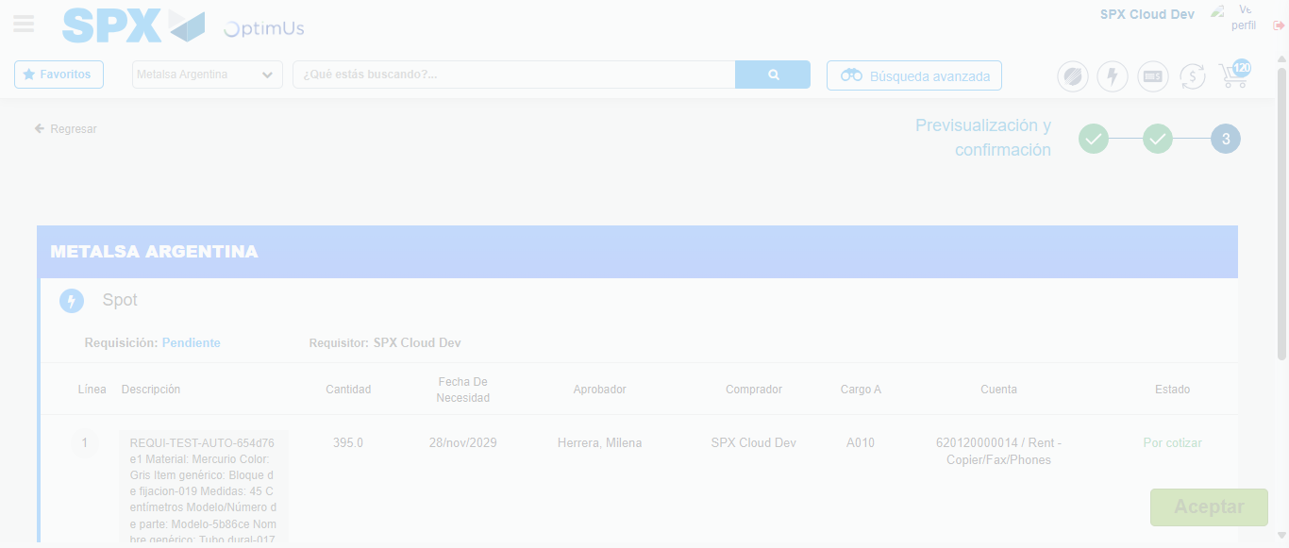Image file-name: QC_Testing-runTestMultipleTimes-nov. 25 2025, 03 33 12 p. m.

Step 6 - Accept to Requisition : Requisition Accepted
Image file-name: QC_Testing-runTestMultipleTimes-nov. 25 2025, 03 33 12 p. m.

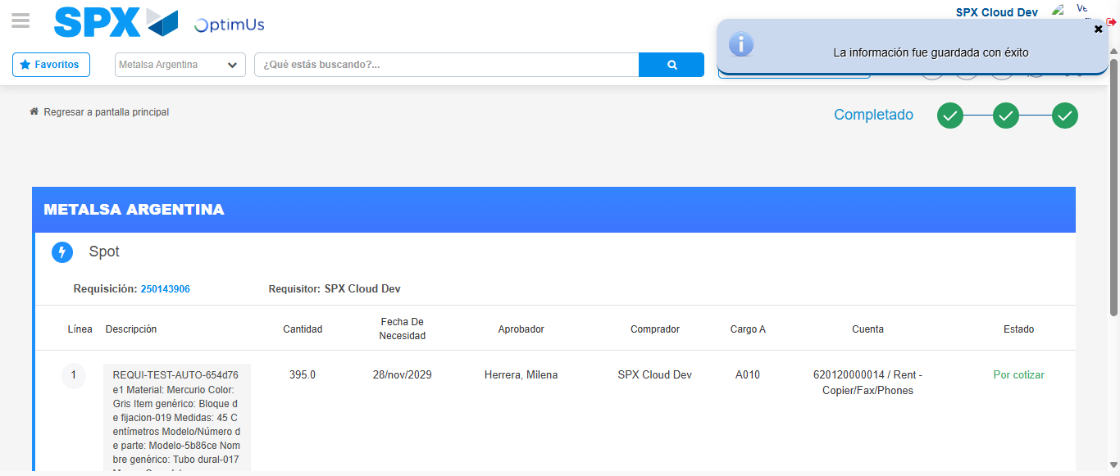Image file-name: QC_Testing-runTestMultipleTimes-nov. 25 2025, 03 33 16 p. m.

